MEMORANDUM
To: All Police and Fire Agencies in King County
From: Central Area Puget Sound Interoperability Committee (CAPSI)
Subject: King County Training Talkgroup Calendar
Date: 3/24/2026

Overview
King County public safety radios now include a KC TRAIN bank of talkgroups used exclusively for public safety training exercises.
These talkgroups follow the same encryption standards as KC IO.
Key notes:
- Talkgroups marked with ^ are encrypted.
- The EMER button functions the same as on KC IO; pressing it reverts the radio to the TRAIN EMER talkgroup, which will be treated as a real emergency by dispatch.
  - IE if you are a police officer on KCTRAIN-02 and you press your emergency button, your radio will revert to the KCTRAIN EM-P talkgroup and a dispatch center will answer you.
  - If you are a firefighter on KCTRAIN^06 and you press your emergency button, your radio will revert to the KCTRAIN EM-F talkgroup and a dispatch center will answer you.
  - The dispatch center who answers may not be your primary dispatch center.
- To coordinate Fire Department Emergency Button training, coordinate with Seattle FAC and NORCOM.

Accessing the Training Calendar
The agency hosting the training is responsible for reserving the needed talkgroups.
Step 1: Request calendar access (hosted by King County IT)
- Go to:
https://kingcounty.gov/en/shared-topics/about-king-county/website/o365-external-terms-of-service
- Enter the following info:
  - King County contact: glen.connolly
  - Agency: KCSO
  - Site URL: “https://kc1.sharepoint.com/teams/KCSO-sheriff-extranet/CAPSI/Lists/King County Training Talkgroups”
- Receive the email invitation and click the CAPSI link.
- Sign in using your agency credentials (email + Windows password).
- Bookmark the page for future use.
Making a Talkgroup Reservation
- On the SharePoint site, select King County Training Talkgroup Calendar (left navigation menu).
  - 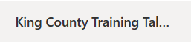
- Choose your preferred view: All Items (List) or Month View (Calendar).
  - 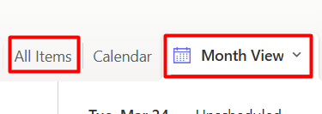
- Verify that your requested talkgroups are not already reserved for the same dates/times.
- Click + Add new item.
  - 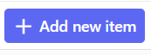
- Fill out the required fields (and optional ones as needed).
  - 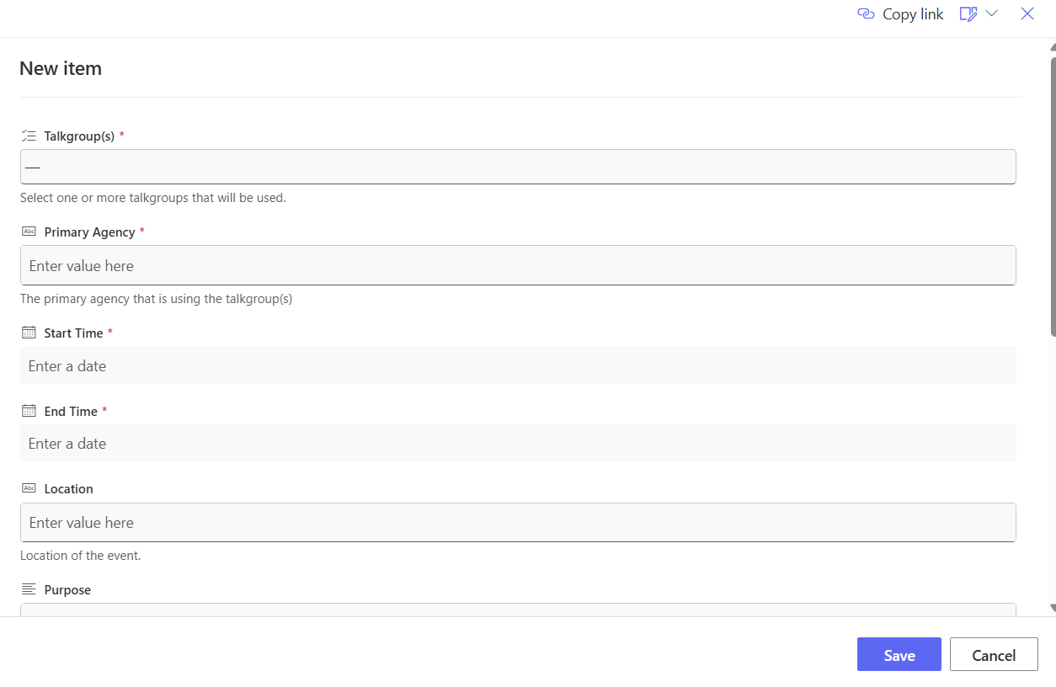
- Click Save.

Available Talkgroups
- KCTRAIN-02
- KCTRAIN-03
- KCTRAIN^04
- KCTRAIN^05
- KCTRAIN^06
- KCTRAIN^07
- KCTRAIN^08
- KCTRAIN^09
- KCTRAIN^10
- KCTRAIN^11
- KCTRAIN^12
- KCTRAIN^13
- KCTRAIN-14
- KCTRAIN-15
- KCTRAIN-EM P
- KCTRAIN-EM F

